*Samsung mobile*

*SAMSUNG GALAXY S10 5G*

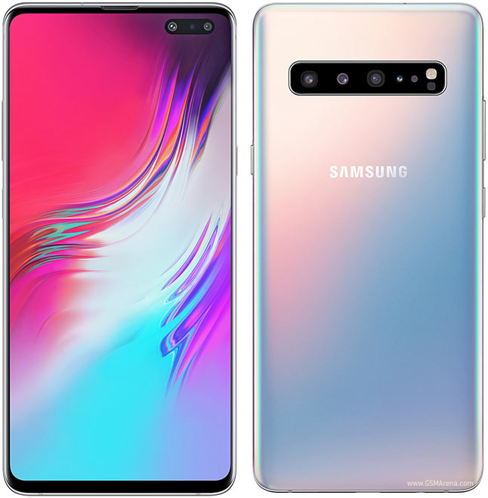

**Samsung Galaxy S10** 5G Android smartphone. Announced Feb 2019. Features 6.7″ display, Exynos 9820 chipset, 4500 mAh battery, 512 GB storage, 8 GB RAM, ...

**PRICE /139,999.00 PRK**